**WIDE WORLD IMPORTERS IN POWER BI**

# **PROJECT REPORT**

HEMANTH POTHINENI [ Z1948105 ]

NORTHERN ILLINOIS UNIVERSITY

Business 661 Intelligence Applications & Tools – OMIS

**SUMMARY**

In this project, we had to analyze the World wide importers database to know how the company is performing in different areas and what changes need to be made to ensure the company remains profitable. Wide World Importers (WWI) is a wholesale novelty goods importer and distributor operating from the San Francisco Bay area. The majority of WWI's clients are businesses that resale to people. WWI purchases products from suppliers such as toy and novelty producers as well as other novelty distributors.

We have used Microsoft power bi for analyzing this data, Power bi allows you to clean, and analyze data and make visuals with the data to provide accurate information to the company or the analyst. WWI database has 4 fact tables and 6-dimension tables.

The orders placed by WWI based on state province are highest in Texas and the lowest in Hawaii and other states based on our analysis. We would recommend improving sales in the states and territories where the orders are low, which is improving the marketing for ex., Hawaii is an Island, and the population is very low but it’s a tourist spot according to that we need to improve the marketing strategies and advertise about the product in rush areas which helps to increase the sales.

When we analyzed the sales of WWI, from the profit by state graph and the revenue and profit% by the quarter graph we got to know that the graphs show the profit % was rapidly dropping every year, so we would recommend that to reduce the operating cost of the products and increase the order value which helps to grow the profit % in sales revenue.

When we analyzed the stocks of WWI, we got to know that certain items are the highest selling and the main profit generators for WWI, but WWI doesn’t maintain enough stock of these items. We can see that for a few stock items, the target level is a little higher, by this we can are trying to recommend that certain stock items need to be replenished.

Upon analyzing the movement of goods from WWI’s warehouse, the sum of quantity by suppliers is more by only 2 suppliers, so we would recommend them to buy from more suppliers to increase their inventory and revenue, and we also recommend that WWI buys different category of goods other than just clothing and packaging suppliers.

Upon analyzing the purchases of WWI, the number of products ordered generates more money than the number of packages ordered, but we would suggest raising even the number of order packages to boost profits for both WWI and the suppliers. Also, instead of investing in new or different items, they should primarily concentrate on growing the ones that are already making them a solid profit, unless the product's functionality is excellent.

After analyzing the transactions made by WWI with its suppliers and customers, we found out that Since client transactions outnumber supplier transactions, they must purchase more goods from suppliers to keep up with rising consumer demand, which could boost their profit. Also, there are only three primary suppliers that WWI purchased from, so they must make sure to speak with other suppliers and purchase from them as well in order to increase sales and satisfy client demand.

**DATA CLEANING**

Data cleaning is the process of repairing or removing incorrect, corrupted, incorrectly formatted, duplicate, or incomplete data from a dataset. When combining multiple data sources, there are numerous opportunities for data to be duplicated or mislabeled. When we drive data cleansing in order to get accurate Power BI reports, there may be blank or meaningless rows that aren't needed for the reports. As we can see, it has a blank row beneath the column header, which can be removed using Power Query.

We clean the data from WideWorldImportersDW, and we deleted the rows like **Latest** Record Population in the dimension city field, WWI Purchase Order ID in Fact Movement Field, Supplier Invoice Number, WWI Purchase Order ID, WWI Supplier Transaction ID, WWI Invoice ID from Fact Transaction Field and deleted the NULL values, Negative values, and some unnecessary columns from the data are Cleaned. We Clean those values to avoid irrelevant answers as the result and to get an accurate result while executing it. Graphical user interface, application, table, Excel

Data preparation is always necessary to avoid data issues and achieve accuracy in the reports. After you've finished sanitizing the data, the system is ready to deliver actionable insights to the workforce, allowing us to make timely and productive decisions. We covered all of the fundamental strategies for Power BI data cleaning.

**DATA MODELLING**

Initially, after loading the data, we removed certain tables that were unnecessary in visualizing the data that is in line with the Business goals and objectives.

These table when viewed in the Data Model had no relationship with the data we were going to use. The tables are – Integration City_Staging, Integration Customer_Staging, Integration Employee_Staging, Integration ETL Cutoff, Integration GenerateDateDimensionColumns, Integration Lineage, Integration Movement_Staging, Integration Order_Staging, Integration PaymentMethod_Staging, Integration Purchase_Staging, Integration Sale_Staging, Integration StockHolding_Staging, Integration Stockitem_Staging, Integration Supplier_Staging, Integration Transaction_Staging, Integration TransactionType_Staging.

The very first place you want to go before doing anything is to go the relationships area, i.e, the modeling area (data modeling). Creating relationships and checking them is absolutely a crucial part of developing anything in power bi.

There are two sorts of main types of tables, lookup tables, and fact tables. The fact table is like your sales table which has all the transactions. A lookup table is like all the tables which are sort of filtering.

I put all the lookup tables on the top in a singular row and fact tables below it because when you ultimately create relationships you can visualize them so easily in your mind. The data modeling layout I have adopted is Waterfall Approach.

Apart from the relationships that Power bi has provided, I have changed a few relations between tables. So, if we go to the model view and go to the manage relationships dialog when using the edit relationship dialog, it’s easy to see not only the tables and columns that will be used for the relationships but also the cardinality and its direction. Ideally, your relationships will be one-to-many or many-to-one cardinality and power bi is good at defaulting the cardinality correctly according to the data.

In the edit relationship dialog, we see the relation, you can choose your cardinality, and make sure it’s in the right direction. I selected single for cross-filter direction according to the data.

Because data modeling is one of the pillars of the power bi data, it's critical to do it right. To completely communicate the organization's information, we must first design a well-developed data model. As a result, data modeling should come directly after data cleaning and shaping.

**DASHBOARDS, DATA ANALYSIS AND VISUALIZATION**

**Orders**

* In the Orders dashboard we show the No. of orders getting per state and revenue for the states getting per order and several buying groups.
* By selecting a particular state we can know about the order details, quantity, and products ordered by the customers.
* We sort the details of the state according to the orders from that state from Descending to ascending.
* We also provided the details of the counts per sales territory and the stocks provided in our warehouses according to WWI DW information.
* We include the Key Influencers to the dashboard to get all the information about every stock item we include in this dashboard.

1. **How many orders did we get according to the state?**

1. **What is the revenue of all states in June 2014?**

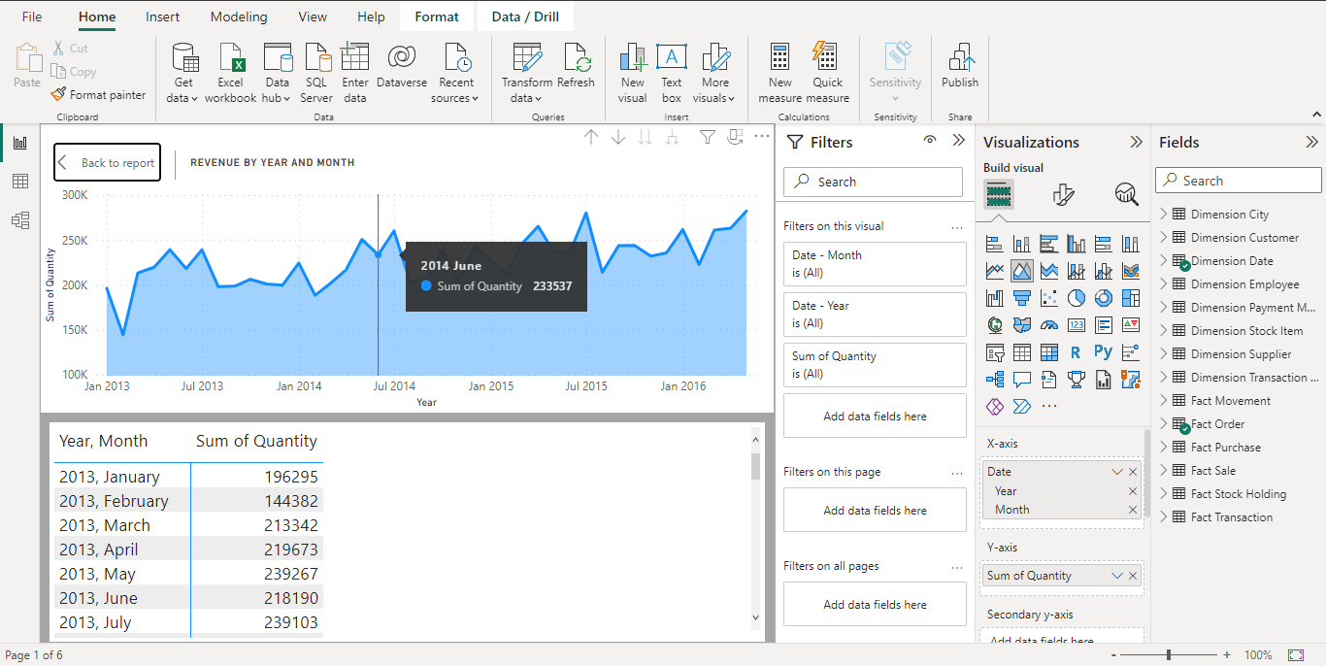

1. **What is the count of the Tailspin Toys group?**

1. **What is the count of the Orders per sales territory?**

1. **Find the average of total excluding tax increases by the air cushion machine?**

**Sales**

* We Include the details of the sales per state and also show about the profit, profit %, and the revenue generated per state.
* I separated the graphs in the dashboard by showing the revenue graph, profit by state, Revenue and % of profit by Quarter, profit by buying group, and the key influencers.
* Every graph is detailed about the respective information according to the information we include in that graph.
* The Key influencers will explain the details of the particular products that we had in WWI DW reports by searching in the Q&A session.
* We mostly include Dimension City, Dimension Date, and Fact sales as the fields for the graphs in this sales Dashboard.

1. **What is the Profit we got from sales from the North Carolina State?**

1. **What is the Profit % in Illinois state?**

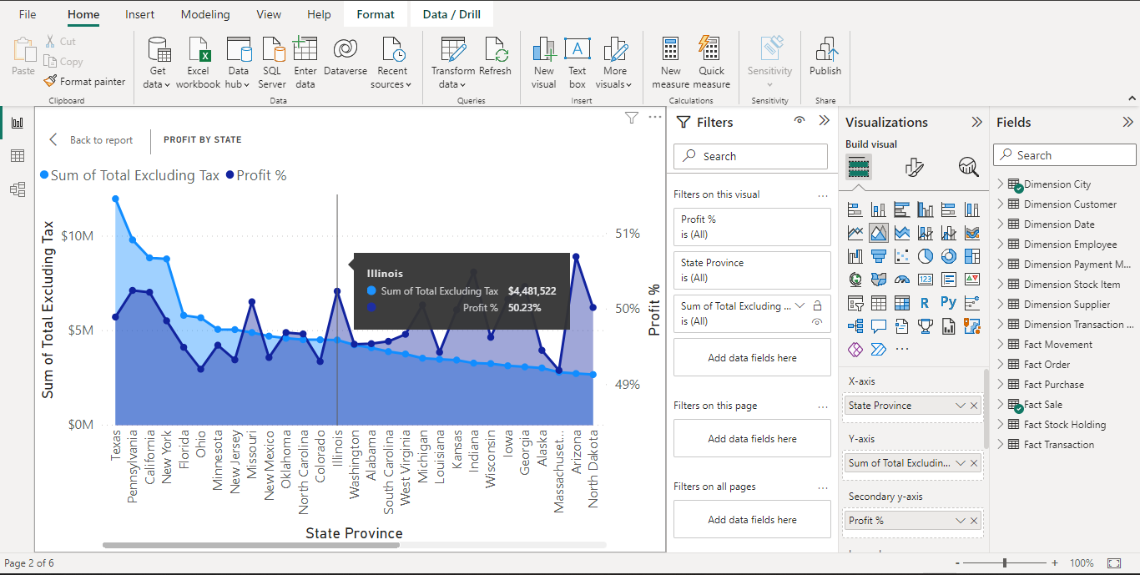

1. **Find the total profit gained by every buying group?**

1. **What is the total revenue gained in the 2nd Quarter of 2015?**

1. **Which stock item has the most profit in Anti Static Bubble Wrap?**

**STOCK**

Data visualization brings data to life by allowing users to produce significant business insights quickly and efficiently using data dashboards, interactive reports, charts, graphs, and other visual representations.

To better understand the data, I have added 4 filters to the stock report page. They are-

* Products- which tells us the total number of products and changes when clicked on any particular data. To achieve this, I have used Stock Item Key column from Fact Stock Holding table.
* Quantity- which tells us the quantity of the stock that is present in the warehouse. I have used Quantity On Hand column from Fact Stock Holding table. It even shows what quantity of stock is in a particular warehouse when you select the warehouse from the visuals below.
* Stock Value- tells us the stock value of the entire stock that is present in all the warehouses. To achieve this, we have created a calculated column i.e, Stock Value in the table Fact Stock Holding.
* Locations- tells us the number of warehouse locations where the stock is stored.

The questions we have formed to better understand and make some recommendations from stock data are as follows:

1. **What is the sum of Quantity On Hand by Bin Location?**

1. **What is the Stock Value by Price Range?**

1. **What is the Sum of Quantity On Hand by Price Range?**

1. **What is the quantity and Stock value of each stock item in the bins?**

1. **What is the Sum of Quantity on Hand and Sum of Target Stock level by stock item?**

**MOVEMENT**

Movement is the stock that is coming in to the warehouse by the suppliers, and the quantity of stock that is being purchased by the consumers.

It is described as Quantity In and Quantity Out.

I have added 4 filters to the stock report page. They are-

* Movements- which tells us the total number of movements of stock(quantity inn and quantity out of the bins). To achieve this, I have used Movement Key column from Fact Movement Table.
* Total Quantity- tells us the total quantity of the stock. I have used Quantity column from Fact Movement table.
* Suppliers- tells us the number of suppliers supplying stock to the warehouse. Supplier Key column has been used from Suppliers table.
* Customers- tells us the number of customers buying stock from the warehouse. Customer Key has been used from the Fact Movement table.

We have provided some AI Insights to this page as well. You may utilize AI Insights in Power BI to obtain access to a set of pre-trained machine learning models that will help you with your data preparation efforts. AI Insights is accessed using the Power Query Editor, and its related features and functionalities are available via the Home and Add Column tabs.

The questions we have formed to better understand and make some recommendations from movement data are as follows:

1. **What is the sum of quantity by Supplier?**

1. **What is the sum of quantity by Category?**

1. **What is the Sum of quantity by Customer?**

1. **What is the sum of quantity by Buying group?**

1. **What is the Quantity IN and Quantity OUT of the warehouse?**

**PURCHASES**

In the Purchases page, we wanted to show the purchases that WWI makes every year, so we added 5 different visuals representing different analyses made from WWI’S purchases.

In the first visual the clustered column chart represents the sum of the Quantity that was Ordered by WWI based on year and months respectively. here we take the following fields ie. the date hierarchy from the Dimension Date table and the Ordered Quantity from the Fact Purchase table.

In the second visual, the Stacked area chart represents the sum of Ordered packages that WWI had ordered based on year and months. here we take the following fields to construct the visual ie. the date hierarchy from the Dimension Date table and the Ordered Outers field from the Fact Purchase table.

The main difference between visual 1 and visual 2 is that visual 1 depicts a single item, and visual 2 depicts a Pack of an item.

In the third visual, the matrix shows the quantity that was ordered by WWI from its Suppliers, based on category and supplier. here we take the category and supplier fields from the Dimension Supplier table and the Ordered Quantity field from the Fact Purchase Table

In the fourth visual, the clustered column chart shows the no distinct or unique products that were bought every month. here we take the date hierarchy field from the Dimension Date table and the stock item key field from the fact purchase table.

in the fifth visual, the decomposition tree represents the sum of the ordered quantity allows you to select from 3 different options, like the products which were the highest selling, lowest selling, and stock items in the order. Here we take the stock item field from the dimension stock item table and the ordered quantity field from the fact purchase table. We also added slicers to the visuals to make them interactive and easily accessible to the user.

1. **What was the sum quantity of Orders that were made By WWI based In the previous years?**

1. **What is the Sum of the Packages Ordered by WWI based on year and month?**
2. **How much quantity did WWI purchase from each supplier?**

1. A picture containing table

   Description automatically generated**How many distinct products were purchased each year by WWI?**

1. A picture containing graphical user interface

   Description automatically generated**Which are the highest-selling, and lowest-selling, and how many stock items are in the sum of the ordered quantity?**

**TRANSACTIONS**

In the Transactions page, we show the number of transactions made by WWI between their suppliers and customers .

The stacked column chart represents the number of Customer transaction s and the number of Supplier transactions made by WWI based on year and month. Here we take the date hierarchy field from the Dimension Date table and the total excluding tax field from the Fact transaction table

The clustered column chart shows the customers who have an outstanding balance with the company. here we take the customer field from the dimension customer table and the outstanding balance field from the fact transaction table.

The treemap shows the outstanding balance that the company has to pay to the suppliers, here we take the supplier field from the Dimension Supplier table and the outstanding balance field from the fact transaction table.

The stacked area chart shows the total revenue excluding tax generated by the company by respective year and month. Here we take the date hierarchy field from the Dimension Date table and the total excluding tax field from the Fact transaction table.

The pie chart shows the revenue generated by customers, here we take the customer field from the dimension customer table and the Total excluding tax field from the Fact Transaction table.

The donut chart shows the revenue generated by suppliers, here we take the supplier field from the Dimension Supplier table and the Total excluding tax field from the Fact Transaction table.

1. **How many customer transactions and supplier transactions were made by WWI based on year and month?**
2. Chart, bar chart

   Description automatically generated**What is the sum of the outstanding balance that the customers have to pay WWI?**

1. **What is the sum of the outstanding balance that WWI has to pay to its suppliers?**

1. **What is the total revenue generated excluding tax by the company by respective year and month?**

1. **How much revenue is generated by Customers for WWI?**

1. **How much revenue is generated by Suppliers for WWI?**

**Recommendations**

* From an order I would recommend increasing sales in states and territories where orders are low, which is improving marketing. For example, Connecticut is the very well-developed state , but it has low orders, so we need to improve marketing strategies and advertise about the product in high-traffic areas to help increase sales.
* From sales We can see from the graphs that the profit percentage is rapidly decreasing year after year. I would recommend that we reduce the production costs of the products and increase the order value and quality in the products, which helps to increase the profit percentage in sales revenue.
* From stock We can see that the target level is slightly higher for a few stock items, implying that certain stock items should be replenished.
* From Movement I would like to recommend that We need to filter and check which Supplier provides what category of items, as well which supplier provides the highest quantity of stock.
* From Purchases Although the number of products ordered generates more revenue than the number of packages ordered, I would recommend increasing both the number of order packages and the number of order products to increase profits for both WWI and the suppliers.
* From Transaction Even though client transactions outnumber supplier transactions, they must buy more goods from suppliers to meet rising consumer demand, which could increase their profit.